Quayem Abbas

JUSTIT BC  24/10/23

ASSIGNMENT 1 (WEEK 1-3)

Table of Contents

**Data and Data Structures**

**Development of Data sets using Excel**

**Introduction to Tableau**

**Reflection**

**Data and Data Structures**

Data security policy:

Implement measures to safeguard data from unauthorised access, breaches, and cyber threats. Data privacy and protection policies. Ensure compliance with data protection regulations such as GDPR, protecting individuals’ personal data.

Data access control policy: Specify who has access to what data, based on roles and responsibilities, to prevent unauthorised access.

Data backup and recovery policy: Established procedures for regular data backups and disaster recovery plans to minimise data loss.

Data classification policy: Categorised data based on its sensitivity and importance to determine appropriate handling.

Data governance policy: Outline roles and responsibilities for managing data, ensuring accountability and consistency.

Ethical data use policy: Promote ethical use of data, addressing issues like bias and discrimination.

Cloud data policy: If using cloud services, defined policies for storing and managing data in the cloud, including security and compliance.

Open data and transparency policy: If applicable determine which data should be made publicly available and under what conditions.

Adhering to these policies helps protect data, maintain its quality, and ensure compliance with legal and ethical standards comma ultimately supporting the organisations goals and reputation.

**Development of Data sets using Excel**

To encrypt the excel workbook with a password, I did the following:

I opened the workbook and then clicked on “file” in the ribbon. I then clicked on “info” and then clicked on “protect workbook”. There was an option to click “encrypt with password” in the drop down menu.

Then I set a password (week1-3). I then clicked OK and saved the workbook. To re-open the workbook, I had to input the password into a dialogue box:

To turn the data into a table, I used the filter button after highlighting everything:



I was then able to sort the data and create the following graph to show the GDP for each country, sorted in descending, and along with the rank: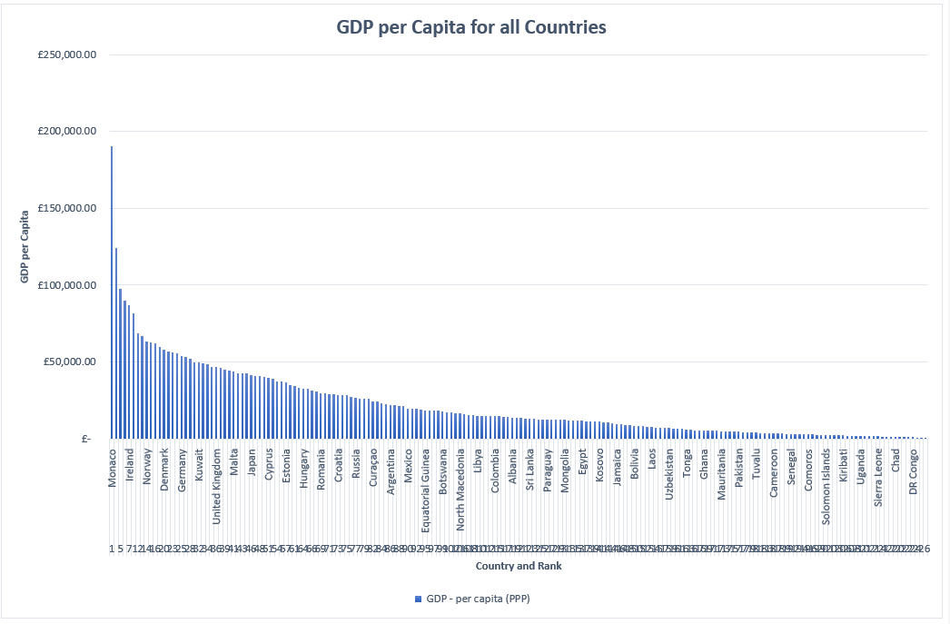

Now I can sort this data to get the Top 20 graphed and then format it along with the table to get: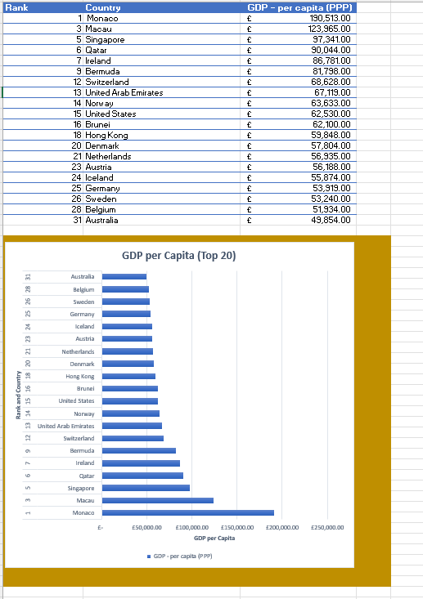

To carry out the macros task, I did the following:

On the developer tab, I clicked “insert” in the controls group. I then selected “button” and drew the button onto the worksheet. The assigned macro dialogue appeared, and I selected the macro that I wanted to create and named it “copy”. I then clicked “record macro” and carried out highlighting the information I wanted to copy. I then right clicked and chose “copy”, and I then stopped the recording. The macros button for copying data was now completed. I then did the same for print where I clicked “file” and then “print”, which created my second macros button. Lastly, for save, I clicked “file”, “save” and created my third macros button.

I used the “copy” macros button to copy the table and graph and paste it:

GDP(GROSS DOMESTIC PRODUCT)

|  |  |  |  |  |
| --- | --- | --- | --- | --- |
| **Rank** | **Country** | **GDP - per capita (PPP)** |  |  |
| 1 | Monaco | £ 190,513.00 |  |  |
| 3 | Macau | £ 123,965.00 |  |  |
| 5 | Singapore | £ 97,341.00 |  |  |
| 6 | Qatar | £ 90,044.00 |  |  |
| 7 | Ireland | £ 86,781.00 |  |  |
| 9 | Bermuda | £ 81,798.00 |  |  |
| 12 | Switzerland | £ 68,628.00 |  |  |
| 13 | United Arab Emirates | £ 67,119.00 |  |  |
| 14 | Norway | £ 63,633.00 |  |  |
| 15 | United States | £ 62,530.00 |  |  |
| 16 | Brunei | £ 62,100.00 |  |  |
| 18 | Hong Kong | £ 59,848.00 |  |  |
| 20 | Denmark | £ 57,804.00 |  |  |
| 21 | Netherlands | £ 56,935.00 |  |  |
| 23 | Austria | £ 56,188.00 |  |  |
| 24 | Iceland | £ 55,874.00 |  |  |
| 25 | Germany | £ 53,919.00 |  |  |
| 26 | Sweden | £ 53,240.00 |  |  |
| 28 | Belgium | £ 51,934.00 |  |  |
| 31 | Australia | £ 49,854.00 |  |  |
|  |  |  |  |  |
|  |  |  |  |  |
| |  | | --- | |  | |  |  |  |  |
|  |  |  |  |  |
|  |  |  |  |  |
|  |  |  |  |  |
|  |  |  |  |  |
|  |  |  |  |  |
|  |  |  |  |  |
|  |  |  |  |  |
|  |  |  |  |  |
|  |  |  |  |  |
|  |  |  |  |  |
|  |  |  |  |  |
|  |  |  |  |  |
|  |  |  |  |  |
|  |  |  |  |  |
|  |  |  |  |  |
|  |  |  |  |  |
|  |  |  |  |  |
|  |  |  |  |  |
|  |  |  |  |  |
|  |  |  |  |  |
|  |  |  |  |  |
|  |  |  |  |  |
|  |  |  |  |  |
|  |  |  |  |  |
|  |  |  |  |  |
|  |  |  |  |  |
|  |  |  |  |  |
|  |  |  |  |  |
|  |  |  |  |  |
|  |  |  |  |  |
|  |  |  |  |  |
|  |  |  |  |  |
|  |  |  |  |  |
|  |  |  |  |  |
|  |  |  |  |  |
|  |  |  |  |  |
|  |  |  |  |  |

**Introduction to Tableau**

I opened Tableau and had to import the “Wealth of Nations” workbook by clicking the “Microsoft excel” connection:

I then connected the three sheets as tables together and linked them using “country” as a join to make it possible to create the data and graphs.



Now I was able to try and link various measures and dimensions together to create my visuals. I made sure that I catered for the clients’ needs when creating and sorting the visuals.

I then added them to a dashboard and saved it in Tableau Public to create a link:

<https://public.tableau.com/app/profile/quayem.abbas/viz/Assignment1-Tableau_16981739140870/Dashboard1?publish=yes>

**REFLECTION**

I have had the opportunity to acquire a diverse set of skills and knowledge, which have deepened my understanding of data management and analysis.

Firstly, learning about the various data policies has been enlightening. Understanding the importance of data privacy, security, and ethical use has emphasised the critical role of responsible data handling in our data-driven world. These policies provide a framework for ensuring data integrity and safeguarding against potential risks.

Secondly, gaining proficiency in creating graphs in excel has opened new avenues for data visualisation. It's a powerful tool to communicate insights effectively, making data more accessible. The ability to transform raw data into meaningful visual representations is an invaluable skill.

Learning how to format cells in excel has allowed for more organised and visually appealing data presentation. Details of cell formatting, like conditional formatting, can greatly enhance the clarity of data, making it more user friendly.

The introduction to using macros to create auto buttons has been a game changer. It simplifies repetitive tasks and automates processes, saving time and reducing the risk of errors. This new found skill is a significant booster in my knowledge.

Moving beyond excel, gaining expertise in importing, joining, and analysing data in tableau has been an exciting journey. Tableau's versatility in handling data from various sources and performing advanced analytics has really impressed me. It has opened doors to more in-depth data exploration.

Creating dashboards in tableau and tailoring them to meet client needs for visuals is a skill I find important. Being able to craft customised, interactive dashboards that provide real time insights has the potential to drive informed decision making for clients.

Throughout this data boot camp, my enthusiasm for learning has only grown stronger. The world of data is continuously evolving, and I am eager to continue learning and expanding my skill set.